**Unit Four: Exploring Arts Around the World**

**Lesson 14: Music and Movement**

Name: __________________________________ Date: _______________________

1. **Circle the word that rhymes with the word in bold letters.**

| **fight** | high | sight | fit | rice |
| --- | --- | --- | --- | --- |
| **twirl** | fill | bring | swirl | wire |
| **feel** | keep | treat | eat | heel |
| **sound** | howl | round | loud | crowd |
| **low** | cow | flop | blow | hove |

1. **Write two words that rhyme with the following words.**
2. bring: _______________________ ________________________
3. crop: __________________________ ___________________________
4. **Use words from the above exercise to write your own rhyme.**

______________________________________________________________________________________________________________________________________________________________________________________________________________________________________________________________________________________________________________________________________________________________



Name: __________________________________ Date: _______________________

1. Fill in the blanks with words from the box to complete the sentences.

| jump | stretch | stomp | bend | dance | jump | touch |
| --- | --- | --- | --- | --- | --- | --- |
| hop | sing | listen | turn | move | touch | feel |

__________________________ to the music.

__________________________the chants.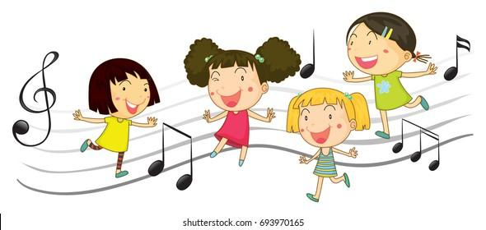

__________________________ your body,

And try to __________________________.

__________________________ to the left.

__________________________the right.

__________________________ your arms,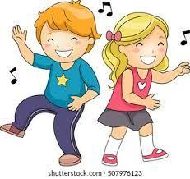

And __________________________ the delight.

__________________________ on one leg.

__________________________ around.

__________________________ your toes,

And _________________________ the ground.



Feel the music!

Feel the beat!

It’s time for you

To ___________________________ your feet.

Name: __________________________________ Date: _______________________

1. **The suffix -less means without a … or that does not … Write the meaning of the following words.**
2. colorless: _______________________________________________
3. helpless: ________________________________________________
4. useless: _________________________________________________
5. careless: ________________________________________________
6. fearless: _________________________________________________
7. endless: _________________________________________________
8. tasteless: ________________________________________________
9. **Use the above words to complete the following sentences.**
10. My lazy dog is _______________________
11. Water is ______________________ and _________________________
12. Parents provide children with _____________________ love.
13. Sometimes people buy ______________________ stuff.
14. My brother is ______________________. He doesn’t feel afraid of anything in world.
15. Some students didn’t solve the math homework. They are ___________________.

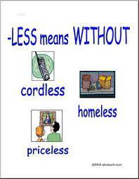

Name: __________________________________ Date: _______________________

1. **Write a short paragraph to describe what is happening the picture below. Use the words in the box.**

| slide | fly | play | build | jump | hop |
| --- | --- | --- | --- | --- | --- |
| run | swing | slide | watch | sing | clap |



